

Civic Buddy

Aim
To analyze the feasibility of the selected software system Civic Buddy – AI Enabled Complaint Tracking System by evaluating its technical, economic, and operational feasibility.

Problem Statement
Urban municipalities receive a large number of complaints related to civic infrastructure such as potholes, open manholes, garbage overflow, water leakage, and damaged streetlights. Currently, these complaints are managed through manual processes, phone calls, or basic online portals that suffer from the following problems:
- Manual complaint classification and routing
- Delay in assigning complaints to the correct department
- Human errors in identifying complaint type
- Lack of automation and intelligent decision-making
- Poor response time and accountability
As cities grow, the volume of complaints increases, making manual handling inefficient and unreliable.

Proposed Solution
Civic Buddy is an AI-powered automated municipal complaint tracking and resolving system that allows users to upload an image of a civic issue (e.g., pothole, manhole). The system uses a Multi-Branch Convolutional Neural Network (CNN) to:
- Automatically classify the type of complaint from the image
- Predict the responsible municipal department
- Automatically route the complaint to the respective department
This reduces manual intervention, speeds up complaint resolution, and improves transparency.

2. System Workflow Explanation
- A citizen captures and uploads an image of a municipal issue.
- The image is uploaded and stored securely in Cloudinary.
- The image is passed to a Multi-Branch CNN model.
- The CNN classifies the complaint type (e.g., pothole, manhole, garbage).
- CNN also predicts the appropriate department.
- The backend receives the classification result.
- The complaint is automatically routed to the respective department.
- The department processes and resolves the complaint.

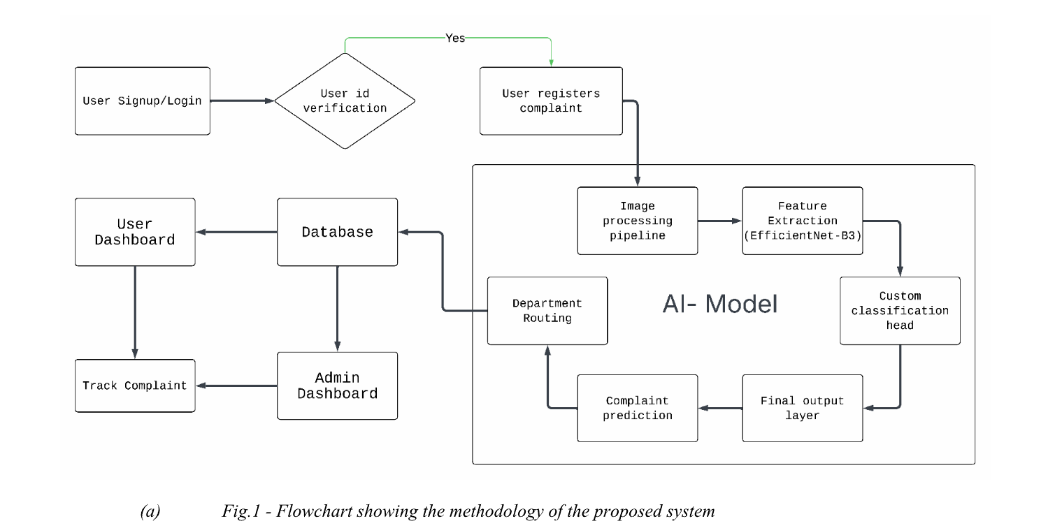

3. Assumptions
Assumptions are conditions that are considered true during system planning and feasibility evaluation.
The assumptions for Civic Buddy are:
- Users have smartphones or devices capable of capturing images.
- Internet connectivity is available for image upload.
- Cloudinary service is available and reliable for image storage.
- Sufficient labeled image data exists to train the CNN model.
- Municipal departments are digitally connected to the system.
- Authorities are willing to use AI-based automation.
- Legal regulations allow digital complaint submission.
These assumptions help in designing the system and assessing feasibility.

4. Constraints
Constraints are limitations that may restrict system development or performance.
The identified constraints are:
- Limited initial budget for AI model development and cloud services.
- CNN model accuracy depends on training data quality.
- Internet dependency for image upload and processing.
- Data privacy and security regulations for user images.
- System scalability issues during high complaint volume.
- Resistance to change from traditional complaint handling systems.
- Time constraints for training and optimizing the CNN model.
These constraints must be managed during implementation.

5. Feasibility Analysis
Feasibility analysis evaluates whether the proposed system can be successfully implemented.
5.1 Technical Feasibility
Technical feasibility checks whether the system can be developed using available technology.
Explanation:
- Image processing and classification using CNNs is a well-established technology.
- Multi-Branch CNN architecture improves accuracy by extracting multiple feature sets.
- Cloudinary supports scalable and secure image storage.
- Backend frameworks can easily integrate AI predictions.
- Automated routing logic can be implemented using APIs and databases.
- Required software tools (Python, TensorFlow/PyTorch, cloud services) are available.
- Skilled developers and open-source libraries support development.

Conclusion:
The Civic Buddy system is technically feasible as it uses proven and accessible AI technologies.
5.2 Economic Feasibility
Economic feasibility analyzes cost-effectiveness.
Explanation:

Costs involved:
- CNN model development and training
- Cloudinary image storage charges
- Cloud hosting for backend services
- Maintenance and model retraining
Benefits gained:
- Reduced manpower required for complaint classification
- Faster complaint routing and resolution
- Reduced operational delays
- Long-term savings for municipal bodies
- Improved citizen satisfaction
Although initial costs are high, automation significantly reduces recurring expenses.

Conclusion:
The system is economically feasible in the long run and provides high return on investment.
5.3 Operational Feasibility
Operational feasibility evaluates real-world usability.

Explanation:
- Citizens only need to upload an image, making the system easy to use.
- No technical knowledge required from users.
- Municipal staff receive already classified and assigned complaints.
- Automation reduces workload and errors.
- Improves transparency, accountability, and response time.
- The system fits naturally into existing municipal workflows.

Conclusion:
Civic Buddy is operationally feasible and user-friendly.

6. Overall Feasibility Conclusion
Based on the technical, economic, and operational feasibility analysis, Civic Buddy – AI Automated Municipal Complaint Tracking and Resolving System is found to be feasible. The system effectively leverages AI to automate complaint classification and routing, thereby improving efficiency, accuracy, and civic service quality.

7. Result
Thus, the feasibility study of Civic Buddy has been successfully completed and the system is found to be feasible for implementation.

